5. Development & Implementation Summary
The MyDiet system is architected as a modular web application consisting of three distinct layers: a reactive Frontend Client, a central RESTful API Server, and a specialized AI Microservice. The Frontend Client handles all user interactions across the five core modules (Homepage, Plan, Identifier, Community, Profile). It communicates with the API Server via asynchronous HTTP requests to retrieve personalized meal plans and synchronize user data, such as daily caloric intake and social posts. A key architectural decision is the isolation of the ‘Identifier’ module: when a user uploads a meal photo, the main server acts as a proxy, forwarding the image data to the AI Microservice. This service processes the image and returns nutritional estimates back through the chain, ensuring the main application thread remains unblocked during heavy computational tasks.
To implement this design, we selected the PERN stack (PostgreSQL, Express, React, Node.js) supplemented by Python.
- Frontend: We chose React.js for its component-based architecture, which allows us to reuse UI elements like the 'Daily Intake' component across different pages.
- Backend & Database: Node.js and Express were selected for their non-blocking I/O, which is ideal for handling real-time community interactions. For storage, we chose PostgreSQL over NoSQL alternatives. Since our "Plan" module relies on strict relationships between user biometrics, ingredients, and weekly schedules, a relational database ensures data integrity and complex querying capabilities.
- AI Service: The image recognition component will be built using Python. We chose Python here simply because it offers the most robust support for machine learning libraries (e.g., TensorFlow/PyTorch), allowing us to implement the food recognition feature more efficiently than if we attempted it in JavaScript.
Our workflow follows an Agile methodology managed via Git to accommodate the ten-week timeline. The process begins with a foundational System & UI Design phase (Feb 23 – Mar 05), where we will finalize the PostgreSQL database schema and UI wireframes to prevent structural changes later. Following this, execution splits into concurrent streams from early March to early April: one sub-team will focus on the Core Development (User Profile, Diet Planning Algorithm, and the Python AI service), while the other implements the Community features. This parallel approach ensures all modules are ready for System Integration (Apr 05 – Apr 19), where we will merge branches, conduct rigorous bug fixing, and finalize the project for the May deadline.

10. UI / UX Mockup
The MyDiet application comprises five primary functional modules: Homepage, Plan, Identifier, Community and Profile. 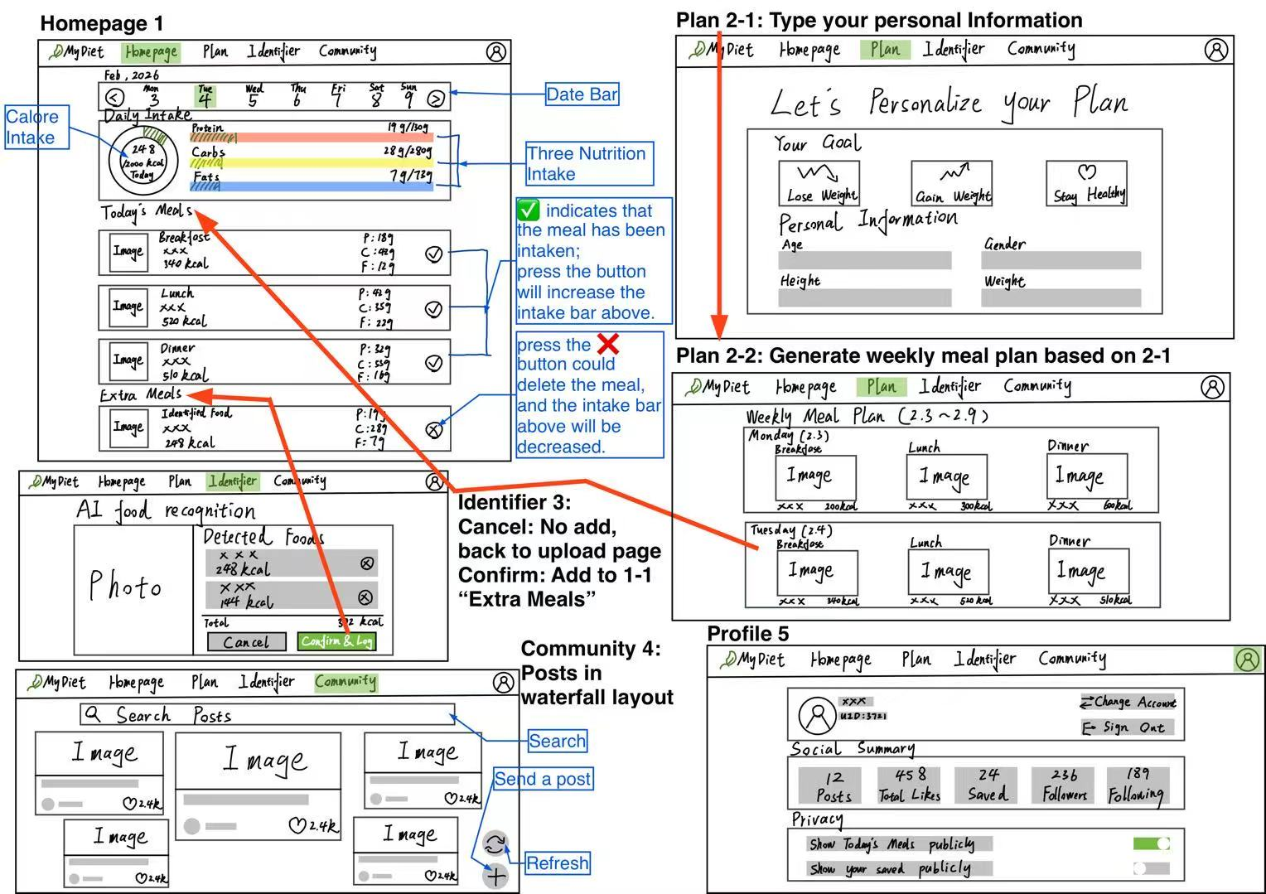
After registration, users are initially directed to Interface 2-1 to provide their personal information. Following data submission, the system transitions to Interface 2-2, where a customized Weekly Meal Plan is algorithmically generated based on the user's biometrical data. Interface 1 features a Daily Intake component; users can modulate values of the component via the Today’s Meals or Extra Meals sections. Furthermore, a Date Bar functionality is integrated to facilitate the retrieval and review of historical intake data. After food photo uploaded and AI-driven analysis, Interface 3 will display the nutritional specifications. Selecting "Cancel" reverts the user to the upload page, while "Confirm" integrates the identified item into the Extra Meals section of Interface 1. Interface 4 serves as a community platform, enabling users to publish, browse, and search for diet-related content. Finally, Interface 5 is the personal information page, where you can view the Social Summary and adjust Privacy.

